|  |  |
| --- | --- |
|  | **Web Designing Assignment**  **Term-1**  **Module (HTML) -1** |

1. **Are the HTML tags and elements the same thing?**

Ans: No, because HTML Tags are building blocks of HTML Page. HTML Elements are components that are used in HTML Page.

1. **What are tags and attributes in HTML?**

Ans: The most commonly used attributes include id, class, src, href, alt, and style. For example, the<img>tag is used to display an image on a web page. In this example, “image. jpg” is the source URL of the image and “This is an image” is the alternative text that will be displayed if the image cannot be loaded.

1. **What are void elements in HTML? With Example**

Ans: A void element is a element that have no closing tag.

Ex: img, hr, br, etc.

1. **What are HTML Entities? With Example.**

Ans: HTML entities are the reserved characters that are used in the HTML document

Ex. using an ampersand (&) with (#) pound character and finally ended with a semicolon;

1. **What are different types of lists in HTML? With Example.**

Ans: There are three types of lists in HTML

* Unordered list or Bulleted list (ul)
* Ordered list or Numbered list (ol)
* Description list or Definition list (dl)

Ex. 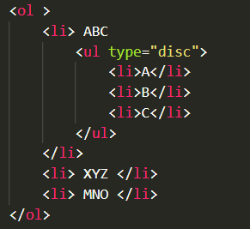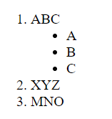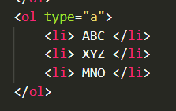 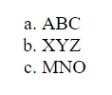

1. **What is the ‘class’ attribute in HTML? With Example.**

Ans: The class attribute specifies one or more class names for an element.

Ex. <span>

1. **What is the difference between the ‘id’ attribute and the ‘class’ attribute of HTML elements? With Example**

Ans:

|  |  |  |
| --- | --- | --- |
| **Key** | **Id** | **Class** |
| Syntax | In HTML, for an element, the ID name starts with the "#" symbol followed by a unique name assigned to it. | "class" assigned to an element has its name starts with "." followed by class name. |
| Selector | Only one ID selector can be attached to an element. | Multiple class selectors can be attached to an element. |
| Uniqueness | ID is unique in a page and can only apply to at most one element | The class can be applied to multiple elements so it could be multiple times on a single page. |

Ex. The syntax for id is: write a hash character (#)

class attributes remain the same for every object and are defined outside the __init__() function

1. **What are the various formatting tags in HTML?**

Ans: HTML provides many predefined elements that are used to change the formatting of text. The formatting can be used to set the text styles (like – bold, italic, or emphasized, etc.), highlight the text, make text superscript and subscript, etc.

1. **How is Cell Padding different from Cell Spacing? With Example.**

Ans: Cell padding is used to create a border around the content area of a web page, whereas cell spacing is used for positioning elements (such as images or text) within that content area

Ex.

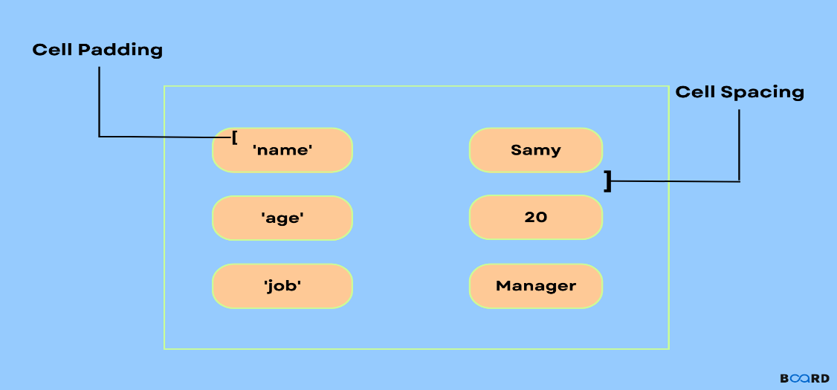

1. **How can we club two or more rows or columns into a single row or column in an HTML table? With Example.**

Ans: We can use colspan and rowspan for club the two or more rows and columns.

Ex.

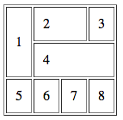

1. **What is the difference between a block-level element and an inline element?**

Ans: Inline elements never begin on a new line. Block elements completely fill the accessible area from left to right. Only the area defined by the tags in the HTML element is covered by inline elements. There are top and bottom margins for block elements.

1. **How to create a Hyperlink in HTML? With Example.**

Ans: We can create hyperlink from anchor tag in HTML.

Ex. 1. <a> </a> Next, add your homepage's URL using the href attribute:

2. <a href="https://www.Youtube.com>My Music</a>

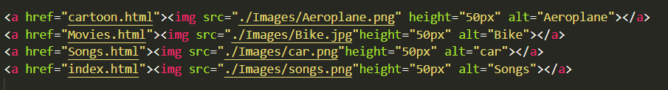

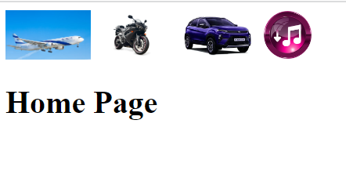

1. **What is the use of an iframe tag? With Example.**

Ans: The iframe tag in HTML stands for **Inline Frame and**is used to embed another HTML document within the current document.

Ex. **Input**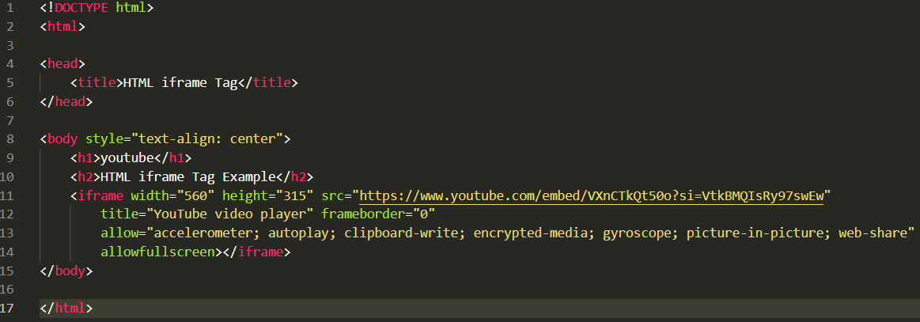

**Output**

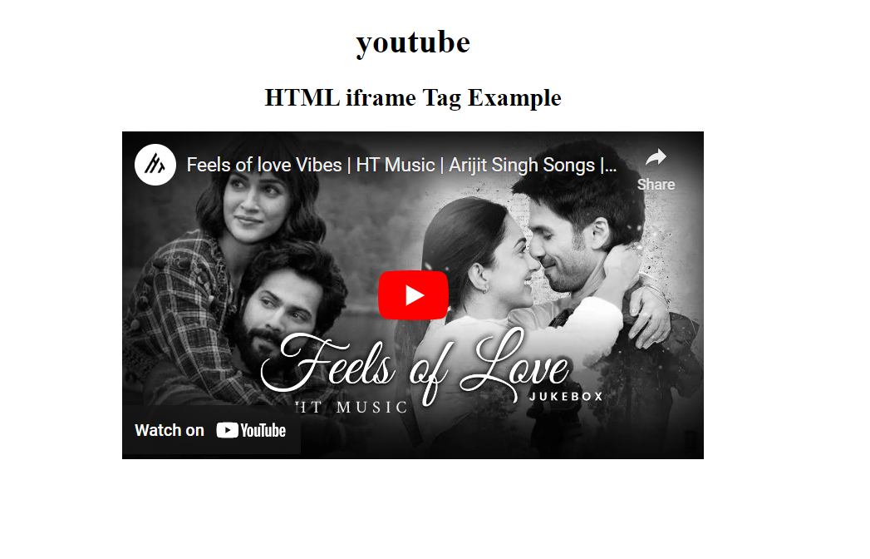

1. **What is the use of a span tag? Explain with example?**

Ans: The span tag is inline tag which is use for change the color or create any formatting in heading or sentence.

Ex. 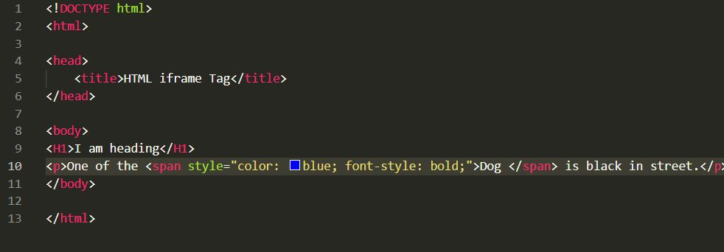

1. **How to insert a picture into a background image of a web page? With Example.**

Ans: The body element is styled to have a background image (background-image), with its size covering the entire viewport (background-size: cover). The background-position: center centers the background image, and background-attachment: fixed fixes the background image while scrolling.

Ex.

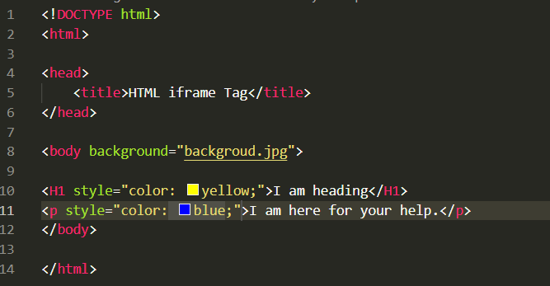



1. **How are active links different from normal links?**

Ans: Active links are typically links that are currently functional and lead to live web pages, while normal links can refer to any link, whether functional or broken. Active links are actively used and accessible, while normal links may or may not be functional at a given time.

1. **What are the different tags to separate sections of text?**

Ans: There are some tags which separate the section of text is as below.

1.<br>

2. <blockquote>

3. <p>

1. **What is SVG?**

Ans: SVG stands for Scalable Vector Graphics. SVG is used to define graphics for the Web.

1. **What is difference between HTML and XHTML?**

Ans:

| **S.No.** |  | **HTML** | **XHTML** |
| --- | --- | --- | --- |
| 1. |  | HTML stands for Hypertext Markup Language. | XHTML stands for Extensible Hypertext Markup Language. |
| 2. |  | It was developed by Tim Berners-Lee. | It was developed by W3C i.e World Wide Web Consortium. |
| 3. |  | It was developed in 1991. | It was released in 2000. |
| 4. |  | It is extended from SGML. | It is extended from XML and HTML. |
| 5. |  | The format is a document file format. | The format is a markup language. |
| 6. |  | All tags and attributes are not necessarily to be in lower or upper case. | In this, every tag and attribute should be in lower case. |
| 7. |  | Doctype is not necessary to write at the top. | Doctype is very necessary to write at the top of the file. |
| 8. |  | It is not necessary to close the tags in the order they are opened. | It is necessary to close the tags in the order they are opened. |
| 9. |  | While using the attributes it is not necessary to mention quotes.  For e.g. <Geeks>. | While using the attributes it is mandatory to mention quotes.  For e.g. <Geeks=”GFG”>. |

1. What are logical and physical tags in HTML?

Ans: (1) Physical Tags: The current HTML and XHTML standards currently provide nine physical styles: bold, italic, monospaced, underlined, strikethrough, larger, smaller, superscripted, and subscripted text.

For Ex. <I>, <u>, <b>,<sup>, <sub> etc.

(2) Logical Tags: Logical Tags are used in HTML to display the text according to the logical styles. Following are the Logical tags commonly used in HTML.

For Ex. <abbr>, <address>,<blockquote>,<pre>,<strong> etc.